**Guided Capstone Project Report**

**Summary of findings and Recommendations**

Big Mountain Resort is trying to find a price strategy, so that the price reflects the market dynamics in the ski mountain resorts in the nation and offer value to customers equivalent to the facilities it has. Using Random Forest modeling, price was determined by using data from 276 different ski mountain resorts and the details of their facilities. Adult-weekend prices was used for modeling. Some of the features that were used to predict the ticket price were vertical drop, snow making in acres, number of total chairs, fast quads, number of runs, longest run-in miles and skiable terrain in acres. Of them, it was revealed that four features such as fast quads, number of runs, snow making acres and vertical drop had significant impact on price. Figure-1 shows the level of importance the features have on price. Figure 3 shows the correlation effects how these variables relate to ticket prices.

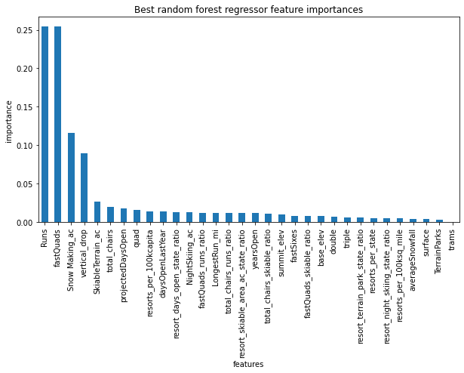

**Figure 1**

The modeled price was $96. Compared to current price of $81, the modeled price is 19% higher than the current price. The modeled price has a mean average error of $10. Hence, it advised that a price for Big Mountain Resort may range between $ 86 and $ 106. We can suggest that given the premium brand that has been built already and the vast number of facilities that it possesses compared to other resorts in the nation (such as skiable terrain area, snow making area, number of runs etc.) charging a price of $96 may do justice for the market dynamics evidenced from the modeling process. However, this price should be implemented with caution as it might bring down the demand for Big Mountain Resort by next year. Currently, it is expected that there will be 350, 000 visitors. But we need to adjust this number as per the new modeled price. Apart from that, with this new price, now it will be possible to cover the operating cost of 1.54M due to the new chair installation discussed earlier in the project.

About the different scenarios considered, closing one run will not have any impact on ticket price, while closing down 2-5 have a smaller reduction and closing 6 or more than 6 will have increased reduction in price. Increasing the vertical drop requires additional installation of chair, so this will be supported by $2 increase per ticket. Increasing the snow making area or longest runs doesn't seem to have any impact on the price.

Although state specific features (population and area in square miles in relation to each resort facilities) were considered initially, since they didn’t show any pattern with the prices, they were dropped later in the analysis. We arrived at the modeled price by using resorts operating in different states; however, it should be noted that operating costs may differ at different states. For example, the labor cost, and maintenance cost in New York may be higher than that in Montana where the Big Mountain resort is. This could be one of the reasons why we got a very high modeled price compared to the current price as we treated resorts from like in California, New york and Montana the same. Coupled with this, taking the vast number of facilities (this is comparatively high for Big Mountain resort) into the modeling process, also soared the price to $96. Figure-2 shows the distribution of prices in each state. Hence, it would be better if we take state specific effects into account, most importantly, the costs in different states should be considered.

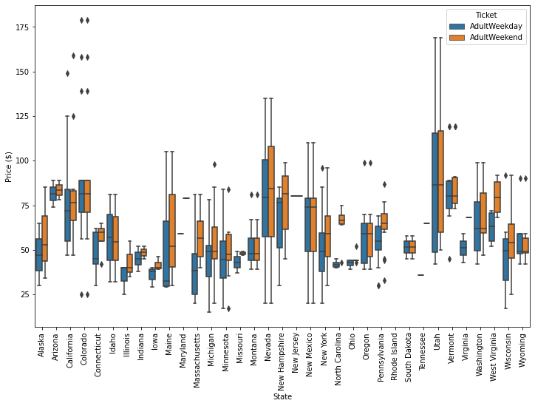

**Figure 2**

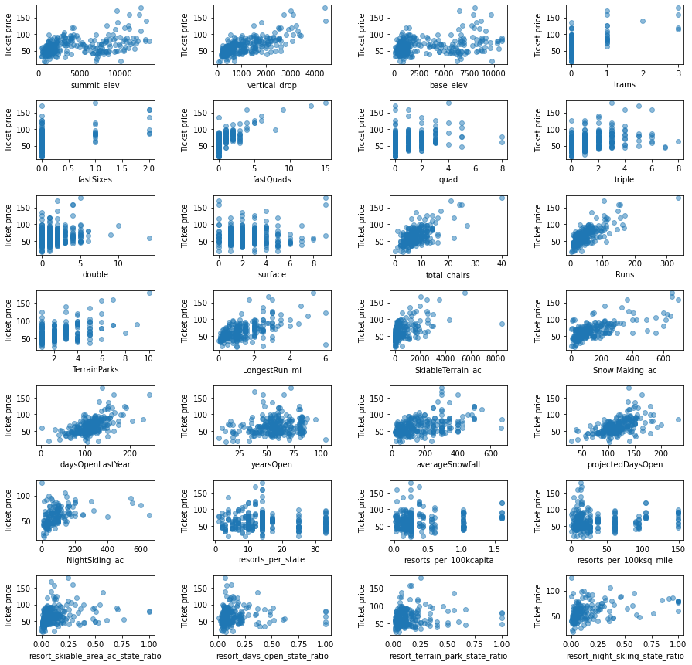

**Figure 3**